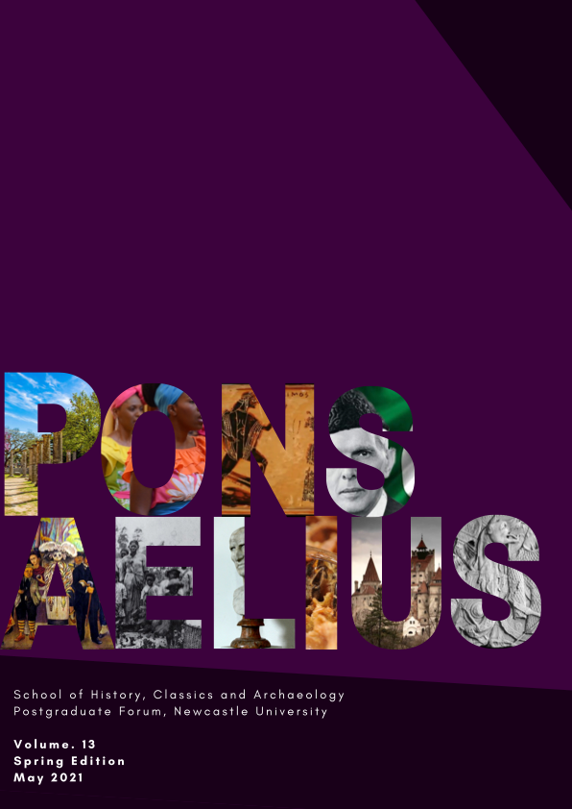
Guide for Contributors
Table of Contents
About the Journal 3
Essential Information 3
Eligibility 3
Paper Format 3
Peer Review 3
A Guide to the Process 4
Submitting an Abstract 5
Word Limit 5
Additional Information 5
Selection Criteria 5
Submitting a Paper 5
Word Count 5
Presentation and Formatting 6
Font 6
Paragraphs and Headings 6
Footnotes 6
Pages and Margins 6
Spelling and Grammar 6
Numbers, Dates and Terminology 7
Illustrations 7
Referencing 8
How to Submit your Paper 9
Pre-Submission Checklist 10
FAQs 10
Contact Us 11

About the Journal

Pons Aelius is the Newcastle University Postgraduate Forum’s e-journal. The Postgraduate Forum is a network of taught and research students studying for postgraduate degrees in History, Classics and Archaeology. The recently re-launched journal aims to highlight the research of our students and draw together work across our disciplines, centred on a common theme.

The journal is open-access and will be published in e-journal format on the PGF’s website, available at: https://www.societies.ncl.ac.uk/pgfnewcastle/e-journal/.

The journal is edited by HCA postgraduate students at Newcastle University. Our current team of editors are:

Journal Editor:
Katherine Waugh

Subject Editors:
Harriet Palin (History)
Craig Thomas (History)
Jerome Ruddick (Classics)
Eleanor Harrison (Archaeology)

Essential Information

Eligibility

Any postgraduate student, or recent graduate from a postgrad degree course, is eligible to submit a paper to the journal. You do not need to be UK based, but all submissions must be written in English.

Paper Format

The primary focus of the journal is on research papers (up to 3,000 words). We also consider submissions of shorter discussion pieces (up to 1,000 words). All papers should be related to the issue theme, which will be announced via a call for papers.

Peer Review

Each submission will be subject to open peer review. This is to ensure the quality and credibility of the research we publish. We aim to make it a positive experience for both parties and it also offers you a chance to go through the peer review process in a safe, friendly environment.

Currently papers are reviewed by their subject editor and one other member of the editorial team.

A Guide to the Process
The following flowchart outlines the key stages of publishing a paper with us, both in terms of your input (green) and our publication process (blue):

Call for Papers
Submit an Abstract
Abstracts go to Editors
Abstract Accepted
Abstract Rejected
Writing the Paper
Check, Proof Read, Submit
Peer Review by Editors
Feedback to Authors
Responses and Revisions
Publication

Submitting an Abstract

Word Limit

Abstracts should be no more than 150 words, excluding the title. Where possible, titles should be concise and do not need to align with the full title of a thesis, for example.

Your abstract, if accepted, will be published alongside your paper and can be edited prior to publication if needed.

Additional Information

We also ask that you include a short academic biography of no more than 100 words. This can include details of your degree programme(s), university affiliation, programme funding and research interests.

If accepted, this biography will appear alongside your paper and can be edited prior to publication if needed. We will also ask for a contact email to be published alongside your paper- this is optional and we will not publish this without your permission.

Selection Criteria

In order to be accepted, abstracts must clearly demonstrate the purpose and context of the research, as well as a degree of originality. They must also link to the theme given by the call for papers.

While we hope to accept as many papers as possible, it is also important to the journal to publish a variety of papers across all our subject areas. As a result, some papers may be rejected only due to the number of submissions. If your abstract is not accepted, please consider submitting it again for a later issue.

Submitting a Paper

Further information about the process of submitting a paper, as well as a style guide, and information on formatting and referencing, can be found in the sections below.

Word Count

Research papers should be no more than 3,000 words. Footnotes are included in the word count, but the bibliography, tables and captions are not.

Discussion pieces should be no more than 1,000 words, including footnotes but excluding bibliography. Discussion pieces may be short discussions of the journal theme, and how it relates to your discipline or research area. These could be experience based essays, or case studies from your work.

Presentation and Formatting

Font
Please use Times New Roman font in size 12 with double-line spacing. Text should be justified, not aligned to the left.

Paragraphs and Headings
Avoid too many short paragraphs, as well as over-long paragraphs.

Please follow this guide to show the level of the section headings in your article:
- First-level headings (e.g. Introduction, Conclusion) should be in bold, with an initial capital letter for any proper nouns.
- Second-level headings should be in bold italics, with an initial capital letter for any proper nouns.
- Third-level headings should be in italics, with an initial capital letter for any proper nouns.

Indent the first line of a new paragraph consistently, except immediately after a sub-heading.

Footnotes
Footnotes should be numbered consecutively (1, 2, 3, etc, not i, ii, iii…) and presented in 1.5 or double-spaced typing as footnotes at the bottom of each page.

Footnotes count as part of the word limit and should primarily be used to referencing. Please note that while footnotes may also be used for translation, clarification and further detail, this should be done sparingly.

Pages and Margins
Margins should be at least 2.5cm (1 inch). Each page of the typescript should be numbered.

Spelling and Grammar

Please use UK English spelling (e.g. -ise). Alternative spellings in quoted material, book and article titles should not be changed.

Quotations should be set in single inverted commas (quotation marks), with double quotation marks only used for a quotation within a quotation. The full stop goes before the closing quotation mark only if the quotation contains a grammatically complete sentence starting with a capital letter. Longer quotations (over three lines) should be indented and separated from the main text by a space above and below, with no quotation marks.

Unnecessary abbreviations and contractions should be avoided.
Capitalisation should be used only for the specific rather than the general. Eg. ‘the queen’, but ‘Queen Elizabeth I’. Offices of state should be capitalised, eg. Prime Minsister. Political parties take capitals ‘the Labour Party’. Likewise, time periods should be capitalised e.g. Neolithic; Iron Age. Political movements do not (communism, capitalism etc.).

Book, journal and newspaper titles should be capitalised throughout. The titles of journal articles and chapters in books should not be capitalised.

Hyphens should be applied consistently, eg. twentieth-century politics.

Please also note:
- i.e. and e.g. not followed by comma.
- Please use the Oxford comma; for example, “a, b, and c”, not “a, b and c”.
- Please avoid writing in the passive tense. ‘Smith argues’ rather than ‘It has been argued by Smith’.

Numbers, Dates and Terminology

Numbers in the text should be spelt out up to ninety-nine and appear as numerals from 100 upwards. The century number should be spelled out in full: the twentieth century. Decades should be presented as follows: ‘the 1930s’, not ‘the 1930’s’ or ‘the Thirties’, and time ranges as ‘2006 to 2008’ rather than ‘2006-2008’.

Broad time periods should be defined within the paper, even if widely accepted within your field.

Calibrated radiocarbon dates should be presented where possible as ‘cal. BC’ and may use a hyphen in the date range.

Words in a language other than English should be italicised, with a translation following if appropriate.

Use Britain/Great Britain only when you intend to include England, Scotland and Wales. Do not use it as a synonym for England. United Kingdom refers to Great Britain and Northern Ireland. The British Isles refers to the United Kingdom and the Irish Republic.

Illustrations

Contributors are welcome to submit illustrations or figures for inclusion within articles. Please note that it is the author’s sole responsibility to obtain the relevant permissions for reproduction of such illustrations from the copyright holder and to make any payments required by the copyright holder.

Illustrations and figures should be submitted:

- In JPG format, separate to your paper.
- At a resolution of at least 300 dpi
- Files should be clearly labelled as “Figure 1.jpg”, “Figure 2.jpg”, etc.
- Please indicate where you wish the figure to be placed in the main text of your paper by inserting [Figure 1 here] where relevant.
- Please include a caption for each figure.

Small tables may be submitted within the text; larger tables should be treated as other figures and submitted in a separate file.

Referencing

Our referencing style is adapted from the Modern Humanities Research Association (MHRA) footnote style. Some choices differ from their standard approach so please read the following information carefully.

This referencing style involves a three-part process:

- Footnote number
- Footnote
- Reference List

1. Footnote number

‘The Persian wars fundamentally changed the political history of mainland Greece^{1’}

The footnote number should be added in text, written in superscript. The number refers to a footnote at the bottom of the page. Footnotes should be added after a quotation, paraphrased material, an idea taken from another author, or another work referred to in text.

2. Footnote

‘1. Osborne 2009: 323’

A corresponding footnote should be inserted at the bottom of the page. Here, a short reference is required with the Author Year: Page format. Later references should repeat the format rather than use Ibid.

Multiple references should be separated by a semi-colon.

For ancient or historical sources please use: Author Work: Location in text.

3. Reference List

‘Osborne, R. 2009. Greece in the Making: 1200-479BC. [Second Edition] London: Routledge.’

A reference list must be provided at the end of the paper. Here all referenced or quoted sources should appear in full and organised alphabetically by author surname.

We do not require a full bibliography of all consulted materials, only a list of those cited.

For a guide on completing full references for different sources, please see below.

Citation in Reference List
Books | Author. Year. Title. Location: Publisher.
Chapters in edited collections | Author. Year. ‘Chapter/Section Title’. Editors. Book Title. Location: Publisher. Section Pages.
Journal Articles | Author. Year. ‘Article Title’. Journal. Volume (Issue). Pages.
Unpublished Dissertations and Theses | Author. Year. Title. University. Unpublished PhD [or other course type] Thesis.
Newspapers | Newspaper Title. Date. Page Number.
Websites | Title of Website (Date, if known) Page Name. Url (Date of Access).
Ancient/Classical Sources | Author. Title of Work. Translated by…(Year) Location: Publisher.

Please note:

Authors with the same surname and year of publication should be distinguished by first initial within the footnotes. Multiple publications for the same year by one author should be distinguished within both footnotes as follows: “Smith 2010a; Smith 2010b” and labelled in a similar fashion on the reference list.

Please use ‘p.--’ for single pages and ‘pp.--’ for page ranges.

The names of up to three authors should be given in full. For works with more than three authors, only the first author’s name should be given, followed by ‘et. al.’.

Secondary referencing should be avoided if possible.

How to Submit your Paper

All papers and figures must be submitted via email to Katherine Waugh (k.waugh3@newcastle.ac.uk). Where possible, papers should be submitted as a Microsoft Word document. Please include your name or initials in the file name.

Images should be submitted as separate, clearly labelled files. Authors must also complete the online form (LINK HERE) to complete the submission process.

FAQs

“I’m not sure if my paper fits the theme, can I submit anyway?”
We welcome different interpretations of our theme but we do ask that there is a link. If you are in any doubt, please contact the editors who may be able to help.

“I wrote an essay I am proud of and it fits the journal theme. Does it matter that I submitted it as part of my degree course?”
We are very happy to accept re-worked essays or papers based on dissertations and research projects, as long as they have not been published elsewhere. Please see our guidance in this document for how it may need to be re-formatted and be aware of new considerations such as image copyright.

“I would like to publish my paper but I am worried about the peer review process”
We understand concerns about peer review, and aim to create a friendly environment and positive experience from the process. Peer review ensures that we publish high quality papers, suited to our journal and its readers. It also allows us to provide you with constructive feedback from your peers, and have a discussion around your topic and research area.

We may ask that you make some changes prior to publication, but these are things that can be discussed and we are highly unlikely to reject your paper as a result of the peer review process.

“I can no longer complete my paper to the deadline, what should I do?”
We understand that you may find yourself in unforeseen circumstances that impact your ability to submit a paper to the deadline. If you are aware of any potential issues, please contact the editors as soon as possible and we can discuss potential accommodations. Please note that last minute accommodations will be more difficult and cannot be guaranteed.

“I have a question not answered here, who can I ask?”
You can get in touch with our editors at any time if you have questions not answered here. Our contact details can be found in the section below.

Pre-Submission Checklist

Title and Abstract
Is the title concise and relevant to the paper topic?
Does the abstract fit the word limit, and accurately reflect the content of the paper?
Main Text
Is the text clearly structured in paragraphs, with clear topic sentences and heading where appropriate?
Is the text correctly formatted according to the Pons Aelius style guide?
Is your paper accessible for an interdisciplinary audience? Are dates given where needed and specialist terms defined/translated?
Referencing
Have you referenced all information derived from third-party sources?
Have you referenced according to our style guide and included a full reference list at the end of your paper?
Proof Reading
Have you checked for spelling, typos and grammatical errors?
Have you checked all footnote references are also in the reference list?
Is the document in a condition to be submitted and given an appropriate file name?

Contact Us

For general enquiries please contact Katherine Waugh (k.waugh3@newcastle.ac.uk)

For responses to feedback and subject-specific questions please contact:
Harriet Palin: h.palin1@newcastle.ac.uk (History)
Craig Thomas: C.Thomas5@newcastle.ac.uk (History)
Jerome Ruddick: j.m.l.ruddick2@newcastle.ac.uk (Classics)
Eleanor Harrison: e.harrison2@newcastle.ac.uk (Archaeology)

