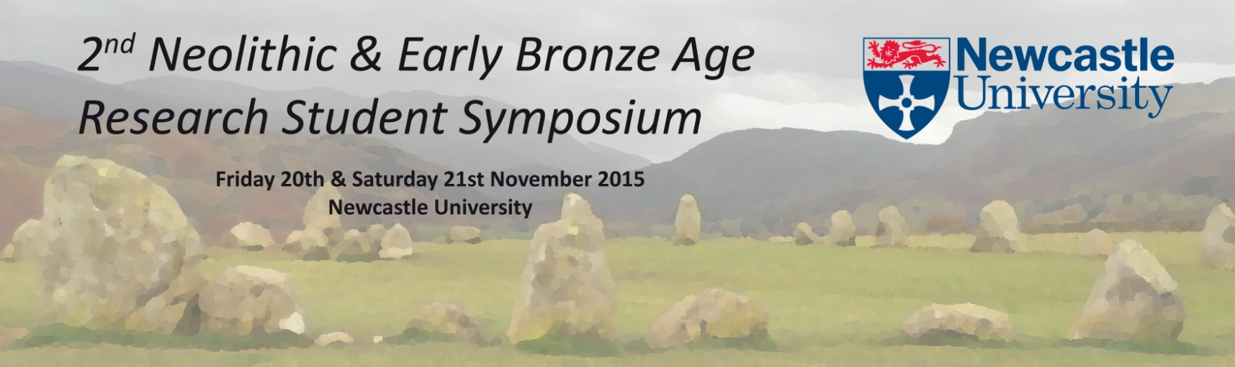
Abstract Submission
Presentations are expected to be between 15-20 minutes long and presented in English. Posters may be bilingual but they must be understandable to English speakers and must be size A1. An abstract in English must also be provided for bilingual posters.
There is no set theme in order for applicants to present aspects of their research as they so wish. Research should focus on any aspect of the Neolithic and Early Bronze Age in Britain and Ireland (papers and posters can include parallels or examples from further afield if it is relevant or an essential aspect of your research, however the focus is on British and Irish archaeology). The conference is for PG research students, early career researchers and independent archaeologist and researchers to present their research in a paper or poster.
Deadline for abstract submission is 1st October 2015
Please return the following form to the conference organisers Lucy Cummings and Mareike Ahlers at: nebarss2015@gmail.com
Name
University or affiliation
Level of study
Email address
Academic website or profile? include link here
Address

Any special or dietary requirements or allergies?
Paper or poster?
Title
Are you happy to have your email address published in the conference pack alongside your name and abstract? |  | Yes / No
Will you be willing to provide an extended abstract for a PDF publication which can be circulated to promote the conference and circulate the research interests and contact details of delegates? |  | Yes / No

Abstract (250-300 words)
Abstract (250-300 words)

